$$RTT=number of hops×2×\left(processing delay+queueing delay+transmission delay\right)+propagation delay$$

10 gigabits per second = 1.25 gigabytes per second

Assuming transmission delay = 60 / 1280000000 = 4.8e-8 sec = 0.048 microseconds

Assuming processing delay = 10 microseconds

Assuming queueing delay = 10 microseconds

Packet size = 60 bytes

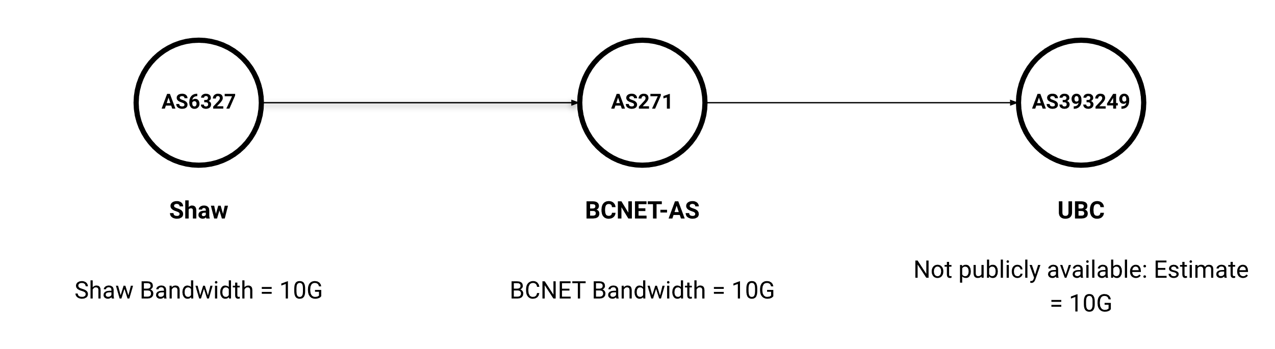

traceroute to ubc.ca (206.87.224.15), 30 hops max, 60 byte packets

Shaw

 1  _gateway (192.168.0.1)  2.468 ms  3.685 ms  3.607 ms

 2  70.77.0.1 (70.77.0.1)  16.291 ms  16.214 ms  16.138 ms

 3  rc3no-be116-1.cg.shawcable.net (64.59.134.133)  18.349 ms  18.269 ms  18.845 ms

 4  24.244.57.181 (24.244.57.181)  18.761 ms  18.681 ms  18.574 ms

 5  24.244.57.5 (24.244.57.5)  21.433 ms  21.346 ms  24.537 ms

 6  rc3no-be214.cg.shawcable.net (24.244.57.1)  24.872 ms  11.151 ms  15.658 ms

 7  rc1st-be11-1.vc.shawcable.net (66.163.72.70)  28.817 ms  27.760 ms  28.167 ms

 8  * * *

 9  208.98.209.22 (208.98.209.22)  33.613 ms  32.009 ms  32.539 ms

BCNET

10  cr2-100g-bb3928ae1.vncv1.bc.net.bc.net (207.23.253.118)  33.214 ms  32.531 ms  32.213 ms

11  134.87.30.149 (134.87.30.149)  34.497 ms  40.860 ms  41.721 ms

UBC

12  137.82.88.122 (137.82.88.122)  31.382 ms  28.457 ms  29.856 ms

13  a22-a0.net.ubc.ca (137.82.123.113)  29.802 ms *  27.090 ms

14  * * *

15  ubc.ca (206.87.224.15)  30.472 ms  30.618 ms  26.526 ms

Shaw Bandwidth = 10G

RTT - home to Shaw edge = 33 ms

Shaw to BCNET number of hops = 9

$$0.033sec=9×2×\left({10}^{-5}sec+{10}^{-5}sec+{4.8×10}^{-8}sec\right)+propagation delay$$

$$propagation delay=0.03264\sec{=32.64ms}$$

BCNET Bandwidth = 10G

RTT - BCNET start to BCNET edge = 4 ms

Shaw to BCNET number of hops = 2

$$0.004sec=2×2×\left({10}^{-5}sec+{10}^{-5}sec+{4.8×10}^{-8}sec\right)+propagation delay$$

$$propagation delay=0.00396\sec{=3.96ms}$$

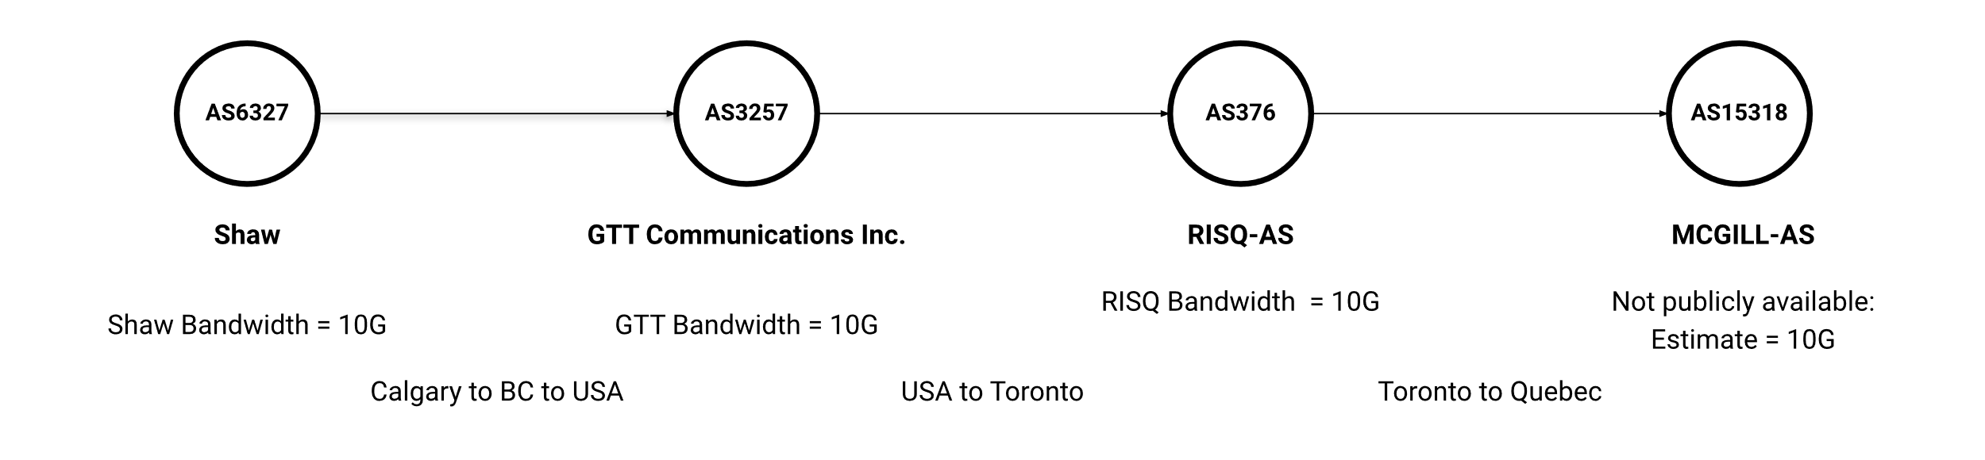

traceroute to mcgill.ca (132.216.177.160), 30 hops max, 60 byte packets

Shaw

 1  _gateway (192.168.0.1)  3.443 ms  3.963 ms  4.640 ms

 2  70.77.0.1 (70.77.0.1)  16.630 ms  19.446 ms  20.041 ms

 3  rc3no-be116-1.cg.shawcable.net (64.59.134.133)  19.979 ms  20.923 ms  21.400 ms

 4  24.244.57.181 (24.244.57.181)  23.232 ms  23.200 ms  25.544 ms

 5  24.244.57.5 (24.244.57.5)  26.602 ms  29.196 ms  28.831 ms

 6  rc3no-be214.cg.shawcable.net (24.244.57.1)  26.246 ms  12.396 ms  17.000 ms

 7  rc3so-be23.cg.shawcable.net (66.163.71.118)  16.971 ms  23.805 ms  23.728 ms

 8  rc1wt-be82.wa.shawcable.net (66.163.76.9)  87.709 ms  87.671 ms  87.532 ms

GTT Communications Inc.

 9  ae22.cr4-sea2.ip4.gtt.net (209.120.141.209)  87.563 ms  87.542 ms  87.520 ms

10  ae16.cr0-mtl1.ip4.gtt.net (89.149.186.134)  102.922 ms  101.716 ms  102.630 ms

11  ip4.gtt.net (208.116.159.206)  104.697 ms  107.626 ms  106.978 ms

RISQ-AS

12  imtrl-rq-ic-dmtrl-rq.risq.net (192.77.63.70)  94.936 ms  95.455 ms  95.417 ms

13  mcgill-gw.risq.net (132.202.62.90)  94.767 ms  235.857 ms  235.774 ms

14  mcgill-internet-membre1.risq.net (206.167.128.42)  235.735 ms  235.705 ms  235.594 ms

15  * * *

16  * * *

17  * * *

MCGILL-AS

18  www.mcgill.ca (132.216.177.160)  212.800 ms  212.822 ms  235.461 ms

Shaw Bandwidth = 10G

RTT - shaw to GTT = 87 ms

number of hops = 8

$$0.087sec=8×2×\left({10}^{-5}sec+{10}^{-5}sec+{4.8×10}^{-8}sec\right)+propagation delay$$

$$propagation delay=0.08684\sec{=86.84ms}$$

GTT Bandwidth = 10G

RTT - GTT to RISQ= 18 ms

number of hops = 3

$$0.018sec=3×2×\left({10}^{-5}sec+{10}^{-5}sec+{4.8×10}^{-8}sec\right)+propagation delay$$

$$propagation delay=0.01768\sec{=17.68ms}$$

RISQ Bandwidth = 10G

RTT – RISQ to MCGILL = 125 ms

number of hops = 6

$$0.125sec=6×2×\left({10}^{-5}sec+{10}^{-5}sec+{4.8×10}^{-8}sec\right)+propagation delay$$

$$propagation delay=0.12476\sec{=124.76ms}$$

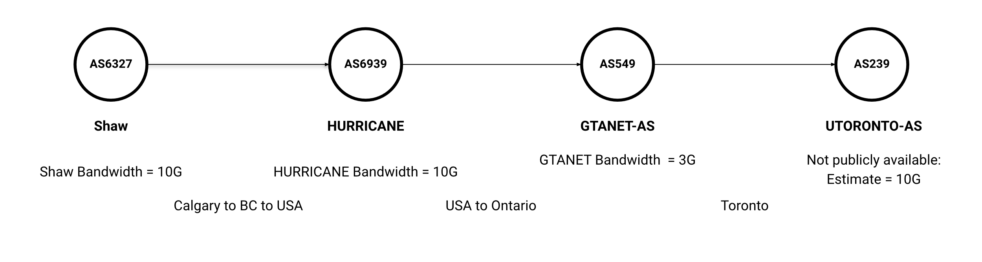

traceroute to utoronto.ca (128.100.166.120), 30 hops max, 60 byte packets

Shaw

 1  _gateway (192.168.0.1)  2.481 ms  3.503 ms  3.486 ms

 2  70.77.0.1 (70.77.0.1)  19.609 ms  21.290 ms  21.874 ms

 3  rc3no-be116-1.cg.shawcable.net (64.59.134.133)  21.923 ms  22.209 ms  22.183 ms

 4  24.244.57.181 (24.244.57.181)  202.875 ms  203.117 ms  202.977 ms

 5  24.244.57.5 (24.244.57.5)  26.460 ms  26.523 ms  26.747 ms

 6  rc3no-be214.cg.shawcable.net (24.244.57.1)  23.703 ms  14.311 ms *

 7  rc3so-be23.cg.shawcable.net (66.163.71.118)  75.934 ms  75.925 ms  76.103 ms

 8  rc1wt-be82.wa.shawcable.net (66.163.76.9)  76.101 ms  76.091 ms  76.092 ms

HURRICANE

 9  100ge14-2.core1.sea1.he.net (206.81.80.40)  76.079 ms  76.074 ms  76.069 ms

10  100ge1-2.core1.msp1.he.net (184.104.194.22)  76.064 ms  76.059 ms  76.049 ms

11  100ge13-1.core2.chi1.he.net (184.105.223.177)  76.173 ms  76.379 ms  76.359 ms

12  port-channel4.core3.chi1.he.net (184.104.196.218)  175.233 ms  235.619 ms  235.679 ms

13  port-channel1.core2.tor1.he.net (184.104.196.246)  234.989 ms  234.980 ms  234.948 ms

14  100ge9-1.core1.tor1.he.net (184.104.196.245)  235.084 ms  235.054 ms  234.791 ms

15  gtanet-networking.10gigabitethernet3-1.core1.tor1.he.net (216.66.30.114)  234.778 ms  234.759 ms  234.875 ms

GTANET

16  utoronto2-ut-hub-if-internet.gtanet.ca (205.211.94.134)  234.754 ms  234.735 ms  234.716 ms

17  * * *

18  * * *

19  * * *

UTORONTO

20  128.100.166.120 (128.100.166.120)  235.784 ms  235.697 ms  235.931 ms

Shaw Bandwidth = 10G

RTT – Shaw to HURRICANE = 76 ms

number of hops = 8

$$0.076sec=8×2×\left({10}^{-5}sec+{10}^{-5}sec+{4.8×10}^{-8}sec\right)+propagation delay$$

$$propagation delay=0.07568\sec{=75.68ms}$$

HURRICANE Bandwidth = 10G

RTT – HURRICANE to GTANET = 76 ms

number of hops = 7

$$0.159sec=8×2×\left({10}^{-5}sec+{10}^{-5}sec+{4.8×10}^{-8}sec\right)+propagation delay$$

$$propagation delay=0.15872\sec{=158.72ms}$$

GTANET Bandwidth = 3G

3 gigabits per second = 0.375 gigabytes per second

Assuming transmission delay = 60 / 375000000 = 1.6e-7 sec = 0.16 microseconds

RTT – GTANET to UTORONTO = 3 ms

number of hops = 4

$$0.003sec=4×2×\left({10}^{-5}sec+{10}^{-5}sec+{4.8×10}^{-8}sec\right)+propagation delay$$

$$propagation delay=0.00284\sec{=2.84 ms}$$